**Project OUI**

**Project Plan**

Project plan for the coffee shop OUI made by the company

Weby Devy/ Group IC-INF-IT1D.

# General information

We are students at NHL Stenden University of Applied Sciences from group: IC-INF-IT1D, and we are managing to create a website for our client: OUI (Lionel Smith). Before making an actual working website, it is crucial to create and develop a project plan.

The name of our client’s future website will be "OUI" and the website will serve as an online profile for our client’s coffee shop. The main purpose of this site is to attract the target age group so customers, after searching and exploring the website, want to visit the client’s shop in the Netherlands. The "OUI" website will have a unique feature called: "French twist" that will add a French atmosphere and excitement to the website’s design. The website will be done in a minimalistic style but with different elements, such as a website header and other functional things. In the future, it will be possible to book a table in the coffee shop and track various events that take place there.

The client wants to create a youthful, playful, and vibrant website. The client wants to add these details so he can create a memorable brand experience that can encourage repeat visits. Additionally, the client wants to incorporate these design elements that persuade customers to buy food from the menu without focusing on the high prices, highlighting that the high quality of their cuisine justifies the cost.

Contractor and owner of OUI:

* Lionel Smith

Weby Devy team:

* Carlos Schaap García
* Rafael Margarido Correia
* Miriam Cerulíková
* David Corodeanu
* Nick Grahovskis
* Ugochukwu Joseph Ndiogazili

**Index**

General information 3

Chapter 1: Background 5

Chapter 2: Project outcome 6

Chapter 3: Project activities 6

Chapter 4: Project boundaries 7

Chapter 5: Intermediate outcomes 8

Chapter 6: Quality 8

Chapter 7: Project Organization 9

Chapter 8: Planning 12

Chapter 9: Cost and Benefits 13

Chapter 10: Risks 14

# Chapter 1: Background

Oui is a coffee shop with a French Twist located in the Netherlands. Its owner, Lionel Smith, wants to attract younger targets and for that reason he has contacted our company “Weby Devy”, he wants a minimalistic, vibrant but doll, youthful and French website to attract more and younger clients from a range of 18 to 30 years old. The client wants a menu with prices.

We are working directly for the owner of the coffee shop, all questions or results we need to provide will be discussed with Lionel.

Carlos Schaap García is the Project Leader and will take responsibility for the result of the project requested by the client.

# **Chapter 2: Project outcome**

The goal of this project is to make an exceptional and unique website for the coffee shop called OUI. It must be a minimalistic, vibrant and French styled website appealing for young audiences.

**Characteristics:**

The web should contain:

* The logo of the coffee shop
* A menu with all the prices included but it does not have to be the first thing to be shown
* It must contain all social media from the coffee shop
* It must contain the location of the coffee shop
* There must be a booking function so people can book a table at the restaurant
* It must be able to show events like the opening event of the coffee shop
* It must have a French aesthetic
* The website must attract a young audience from 18 to 30 years old

The Project must be done by 10/25/24.

# Chapter 3: Project activities

* Week 1:
  + The group will contact the client and get a general idea of the project and what the client wants.
  + The group will create a Project plan.
* Week 2:
  + The group will analyse what the client’s assignment and see the project’s scope and submit an improved Project plan.
  + The team will make an interactive design analysis.
  + Each team member will start working individually on the first draft.
* Week 3:
  + The group arranges a meeting with the client and discusses the first version of our website design. Afterwards, we adjust the design accordingly to the client’s feedback.
  + By the end of the week the group finishes the adjustments and delivers the new version to the client.
* Week 4:
  + The design is tested through a usability test.
* Week 5:
  + The team works the whole week on designing the website and creating a final iteration.
  + At the end of the week, we will meet with the client and hand in the results of the usability test and the final iteration.
* Week 6:
  + The whole team works together on making the website an interactive product striving for maximum quality.
* Week 7:
  + The project is almost completed, just adding the finishing touches.
* Week 8:
  + The group has finished the website and will have a presentation for the client and deliver the final product, including a version control system and a file archive.

# Chapter 4: Project boundaries

* The project has a duration of 8 weeks and by the end it needs to be satisfactory for the client.
* The team will only do the website for the client and answer project related questions.
* It is necessary for the project/webpage to be handed in completed and fully functional to the client and respect /implement all his realistic demands and wishes.
* There will be no inappropriate or explicit content shown on the website, STW only!

# Chapter 5: Intermediate outcomes

|  |  |
| --- | --- |
| **By the end of week** | **What should be done** |
| 1 | The group gets the instructions from the client and works on a project plan. |
| 2 | The group will have analysed the assignment, submit a finalized project plan and hands in the first draft to the client. |
| 3 | Everyone adjusts the design of the website following the client’s feedback and hands in the second draft. |
| 4 | The design underwent a usability test. |
| 5 | The third and final draft is finished and showed to the client together with the results of the usability test. |
| 6 | The website has a menu. |
| 7 | The website is fully functional and finalized. |
| 8 | The final product, version control systems and file archive are presented and delivered to the client, he is being happy with the results, thus the project ending in a success. |

# Chapter 6: Quality

We as company make sure the quality of the project is maximized by keeping in contact with our client as much as possible, by doing that we can tweak the project to make it meet the needs and expectations of our client.

Keeping things organized is a key factor in controlling the quality. Having a project manager or a leader can guide the team throughout the project making sure we’re sticking to the requirements, while understanding them and assure they’re achievable within our budget and deadline.

We also follow this list as method to make sure we provide the best quality:

1. Consistent font size
2. Consistent font name
3. Consistent text alignment
4. Consistent layout
5. Optimised coding
6. Everyone must put the same name for variables
7. The communication between workers has to be exceptional, if there are any problems workers should try to get help from other workers.
8. The communication between workers and the client has to be brilliant so we both know what is going on with the project and what is going to be delivered.
9. Workers should ask for second points of view in order to get feedback.
10. We should do tests regularly in order to know how the state of the project is.
11. Each week we should discuss the state of the project, so everything is done effectively.

# Chapter 7: Project Organization

We have distributed the group in 5 roles:

* **Leader**, takes responsibility for the project, ensures the project is correctly done and organizes the work, so every member has clear what they have to do and make weekly reports about how the project is going. This position is taken by Carlos.
  + Carlos Schaap García  
     [carlos.schaap.garcia@student.nhlstenden.com](mailto:carlos.schaap.garcia@student.nhlstenden.com)
* **Co-leader**, who is also working closely with the leader and ensures that all members are effectively doing their part. This position is taken by Rafael.
  + Rafael Margarido Correia  
     [rafael.margarido.correia@student.nhlstenden.com](mailto:rafael.margarido.correia@student.nhlstenden.com)
* **Secretary**, who is in control of the communication, documentation and the organization of the project itself, it's the one communicating with the client. This position is taken by Miriam.
  + Miriam Cerulíková  
     [miriam.cerulikova@student.nhlstenden.com](mailto:miriam.cerulikova@student.nhlstenden.com)
* **Quality Control**, who is entitled to check if the text has the same layout and font size throughout the whole project and ensure the quality of it. This position is taken by David.
  + David Corodeanu  
    [david.corodeanu@student.nhlstenden.com](mailto:david.corodeanu@student.nhlstenden.com)
* **Designer**, who shapes the visual of the project, making it appealing and as user-friendly as possible. This position is taken by Nick.
  + Nick Grahovskis  
    [nick.grahovskis@student.nhlstenden.com](mailto:nick.grahovskis@student.nhlstenden.com)
* **Web Developers**, who takes charge of the website coding and development. This position is taken by everyone.
  + Ugochukwu Joseph Ndiogazili [ugochukwu.ndiogazili@student.nhlstenden.com](mailto:ugochukwu.ndiogazili@student.nhlstenden.com)

Knowing the surroundings of our project lets us know how to proceed and end up reaching success. To get this information, we make an environmental analysis. In this case we decided a SWOT analysis is the most fitting.

* **Strengths**

Communication

Teamwork

Creativity  
Adaptability

* **Weaknesses**

Language Barrier

Small Team

No Experience with the members

* **Opportunities**

Skill Develpment

Earning Experience

Develop Responsibility

* **Threats**

Members could change groups any day

Resisting changes, which could lead to conflicts

The communication is a key factor in our project. Our ways of communicating base in WhatsApp, Discord, Outlook and of course our in-person meetings. If a meeting is necessary, those would be our ways of communicating to set it up.

We won’t do any weekly reports aside from the meetings in person with our client Lionel.

To keep things organized we also use OneDrive to archive and store files.

# Chapter 8: Planning

The plan was made according to the project activities in Chapter 3.

Tasks are activities which must be done to continue and successfully finish the project. End date is the time the tasks should be done, it is the day before the actual deadline, so if there is a problem, the Task can be still finished on time.

The plan has different types of activities, which must be done either in a group or individually.

The group members agreed to work on tasks for the whole week including weekends, which is considered in the planning.

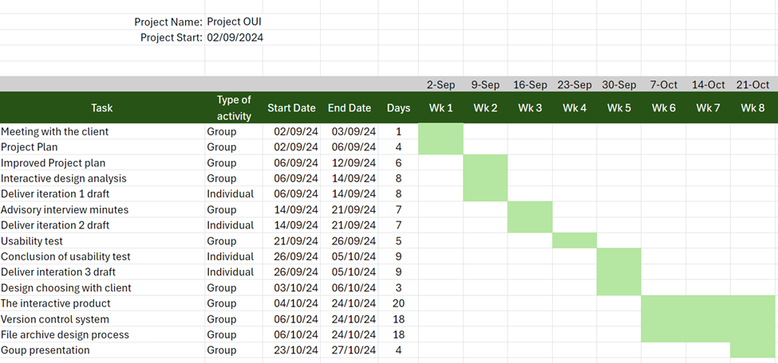

# Chapter 9: Cost and Benefits

In consultation with the client Lionel Smith, the budget has been decided to be 5 000€.

The expected costs might change in the process of realization of the project.

The costs are of the project are:

|  |  |
| --- | --- |
| Man-hours (required working time) | 2 500€ |
| Additional costs for employees (vocations, meals for employees...) | 400€ |
| Materials (paper, pens, mouse...) | 100€ |
| Services (subscriptions, maintenance...) | 200€ |
| Risk budget | 200€ |
| Insurances | 100€ |
| Workspace (rent, energy, water...) | 900€ |
| Equipment | 600€ |
| Summary | 5 000€ |

The benefits of the project are:

* Propagation of the cafe and its products.
* Improves communication with customers and understanding their needs.
* The website will attract the target age group.
* The client expects an increase of sales by 25% in the following year after finishing the project.

# Chapter 10: Risks

The risk is a possible danger of not completing the project on time.

Value is a measure of the risk.

Factor is a value between 0 and 1. Meaning of 0 is, that it’s most definitely not going to happen. 1 means, that it’s most probably going to happen.

Weight is the harm on the project if the risk happens. It's measured with the same system as the factor.

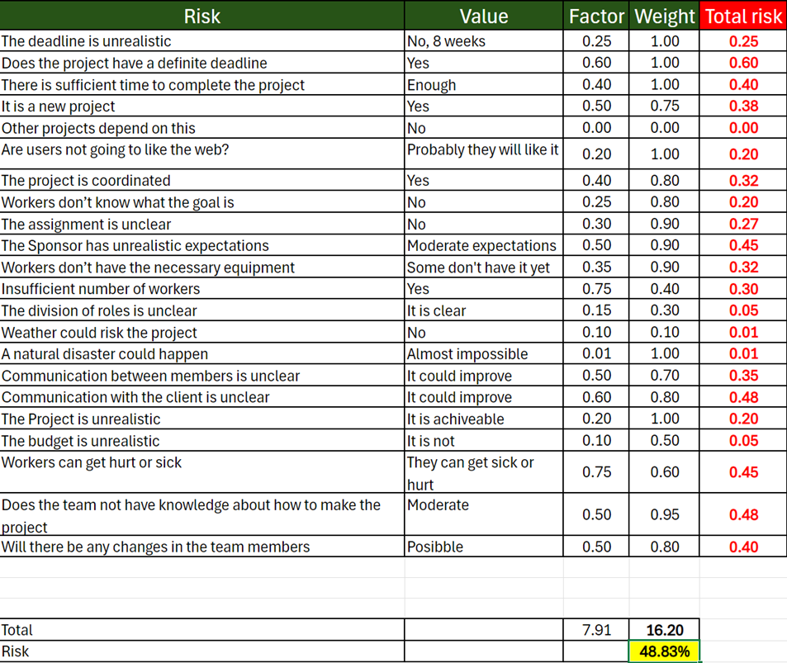

The risk of this project is high, however a successful completing of the project is possible. Each week the project team will adjust the used methodology to make the risk as low as possible.

If a risk is met, we will sit down and discuss it between the group members.

There are two risks that can only be met on the first weeks of the project, those are insufficient number of workers and workers don’t have necessary material, after the first two weeks these problems should have been solved thus reducing the risk of the project.